DEC 2022 : ENTERTAINMENT CALENDAR BIDDEFORD
BURGER Of The Month: “THE BURGER”

SUNDAY | MONDAY | TUESDAY | WEDNESDAY | THURSDAY | FRIDAY | SATURDAY
 | $5 MARGARITAS |  | 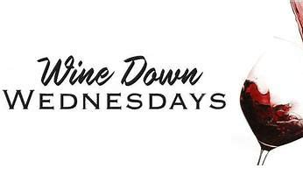  Featuring NEW WINES* | 1  PHILLY/HOU  TALLS FOR  SMALLS | 2  * LIVE MUSIC*  MIKE & PAUL  7pm | 3  RAY ST CYR & MELISSA PROCIDA  7pm
4  MUG CLUB  PATS/INDY 1pm | 5 $5 MARGARITAS  ACOUSTIC OPEN  JAM 7pm | 6 ELECTION DAY  7pm | 7  $5 House Wine  $5 Off Bottles | 8  ATL/CAR  TALLS FOR  SMALLS | 9  * LIVE MUSIC*  KRYSTIAN Beal 7pm | 10  KITTY & JT  7pm
11  MUG CLUB  PATS BYE | 12 $5 MARGARITAS  ACOUSTIC OPEN  JAM 7pm | 13  7pm | 14  $5 House Wine  $5 Off Bottles | 15  TENN/GB  TALLS FOR  SMALLS | 16  * LIVE MUSIC*  KRIS HYPE  7pm | 17  BEN LYONS  7pm
18  MUG CLUB  PATS/JETS 1pm | 19 $5 MARGARITAS  ACOUSTIC OPEN  JAM 7pm | 20  7pm | 21  $5 House Wine  $5 Off Bottles | 22  TALLS FOR  SMALLS | 23  * LIVE MUSIC*  QUIOT RIOT  ACT 7pm | 24  Christmas Eve  Patriots 1pm  Closing after game
25  Merry XMAS !  CLOSED | 26 $5 MARGs  ACOUSTIC OPEN  JAM 7pm | 27  7pm | 28  $5 House Wine  $5 Off Bottles | 29 | 30  * LIVE MUSIC* | 31

