CALENDAR- SCARBOROUGH: MAY 2022
BURGER OF THE MONTH “ QUESA-CINCO ” BURGER
SUNDAY | MONDAY | TUESDAY | WEDNESDAY | THURSDAY | FRIDAY | SATURDAY
MUG CLUB  MEMBERS!  Sundays are for You! | MONDAYS ARE  FOR $5 MARGARITAS  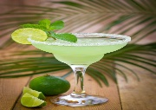 | 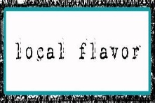$4 Maine Crafts  $7 Maine Spirits | 7pm  SHIPYARD SPECIALS | 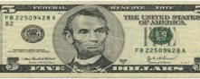  Drinking w/ LINCOLN!  All Drafts $5 | 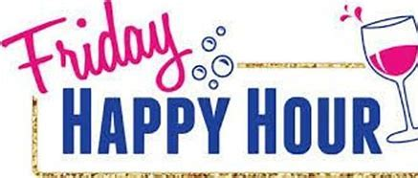  FRIDAY KARAOKE  700 pm | 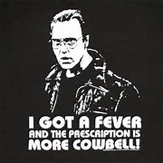
1  MUG CLUB DAY!  $4 SELTZERS | 2 MONDAYS  $5 MARGARITAS 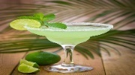 | 3  $4 Maine Crafts  $7 Maine Spirits | 4  7pm  SHIPYARD SPECIALS | 5 CINCO DE MAYO  Drinking w/ LINCOLN!  All Drafts $5  MARGARITA SPECIALS! | 6  FRIDAY KARAOKE  700pm | 7  LIVE MUSIC 630  2 For Jackson
8  MUG CLUB DAY!  $4 SELTZERS | 9 MONDAYS  $5 MARGARITAS | 10  $4 Maine Crafts  $7 Maine Spirits | 11  7pm  SHIPYARD SPECIALS | 12  Drinking w/ LINCOLN!  All Drafts $5 | 13  FRIDAY KARAOKE  700 pm | 14  LIVE MUSIC 630  MIKE MELLEN
15  MUG CLUB DAY!  $4 SELTZERS | 16 MONDAYS  $5 MARGARITAS | 17  $4 Maine Crafts  $7 Maine Spirits | 18  7pm  SHIPYARD SPECIALS | 19  Drinking w/ LINCOLN!  All Drafts $5 | 20  FRIDAY KARAOKE  700 pm | 21  LIVE MUSIC 630  DAS WULF  w/ JIM BRADY
22/29  MUG CLUB DAY!  $4 SELTZERS | 23 /30 MONDAYS  $5 MARGARITAS | 24/31  $4 Maine Crafts  $7 Maine Spirits | 25  7pm  SHIPYARD SPECIALS | 26  Drinking w/ LINCOLN!  All Drafts $5 | 27  FRIDAY KARAOKE  700 pm | 28  LIVE MUSIC 630  NO MUSIC

