 |  | WINE & DINE!  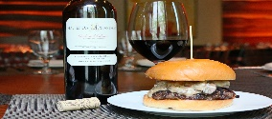  $20 Bottles of Wine | $5 MAINE CRAFTS  $7 MAINE LIQUOR | THURS. $5 TAPS  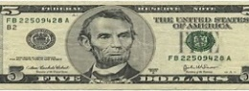  Drinking w Lincoln !
1  ALL DAY HAPPY HOUR | 2  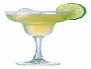  Margarita  Monday | 3 WINE & DINE!  $20 Bottles of Wine | 4  $5 MAINE CRAFTS  $7 MAINE LIQUOR | 5  CINCO DE MAYO  Margarita  SPECIALS! | 6  MIKE  KRAPOVICKY  630 pm | 7  PETER  CARRIVEAU  630 pm
8  ALL DAY HAPPY HOUR | 9  Margarita  Monday | 10 WINE & DINE!  $20 Bottles of Wine | 11  $5 MAINE CRAFTS  $7 MAINE LIQUOR | 12  THURS. $5 TAPS  Drinking w Lincoln ! | 13  JUSTIN CARVER  630 pm | 14  MATT  FOURNIER  630 pm
15  ALL DAY HAPPY HOUR | 16  Margarita  Monday | 17 WINE & DINE!  $20 Bottles of Wine | 18  $5 MAINE CRAFTS  $7 MAINE LIQUOR | 19  THURS. $5 TAPS  Drinking w Lincoln ! | 20  DAS WULF  630 pm | 21  LEE STEARNS  630 pm
22/29  ALL DAY HAPPY HOUR | 23/30  Margarita  Monday | 24/31 WINE & DINE!  $20 Bottles of Wine | 25  $5 MAINE CRAFTS  $7 MAINE LIQUOR | 26  THURS. $5 TAPS  Drinking w Lincoln ! | 27  NO MUSIC  MEMORIAL DAY WKD | 28  NO MUSIC  MEMORIAL DAY WKD
MAY : ENTERTAINMENT CALENDAR
BURGER of the Month: “QUESA-CINCO” BURGER

april : ENTERTAINMENT CALENDAR
BURGER of the Month: “ JUICY LUCY ”BURGER

