CALENDAR- SCARBOROUGH: JANUARY 2023
FEATURE OF THE MONTH “THE ANIMAL BURGER”
SUNDAY | MONDAY | TUESDAY | WEDNESDAY | THURSDAY | FRIDAY | SATURDAY
1  ALL DAY HAPPY HOUR  PATS/MIA  1pm | 2  BOWL GAMES | 3  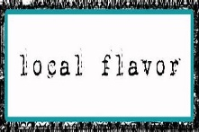$5 Maine Crafts  $7 Maine Spirits | 4  7pm  SHIPYARD SPECIALS | 5 THURSDAY MUSIC  *DON CAMPBELL*  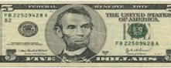  Drinking w/ LINCOLN!  All Drafts $5 | 6  FRIDAY KARAOKE  7pm | 7  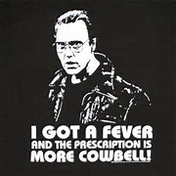  NEW LIVE MUSIC SERIES  RAY ST CYR 6pm
8  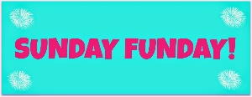  MUG CLUB DAY!  PATS/BUF  1pm | 9 MONDAYS  $5 MARGARITAS 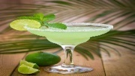 | 10  $5 Maine Crafts  $7 Maine Spirits | 11  7pm  SHIPYARD SPECIALS | 12  Drinking w/ LINCOLN!  All Drafts $5 | 13  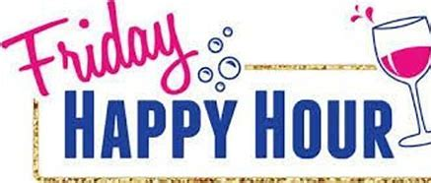  FRIDAY KARAOKE  7pm | 14 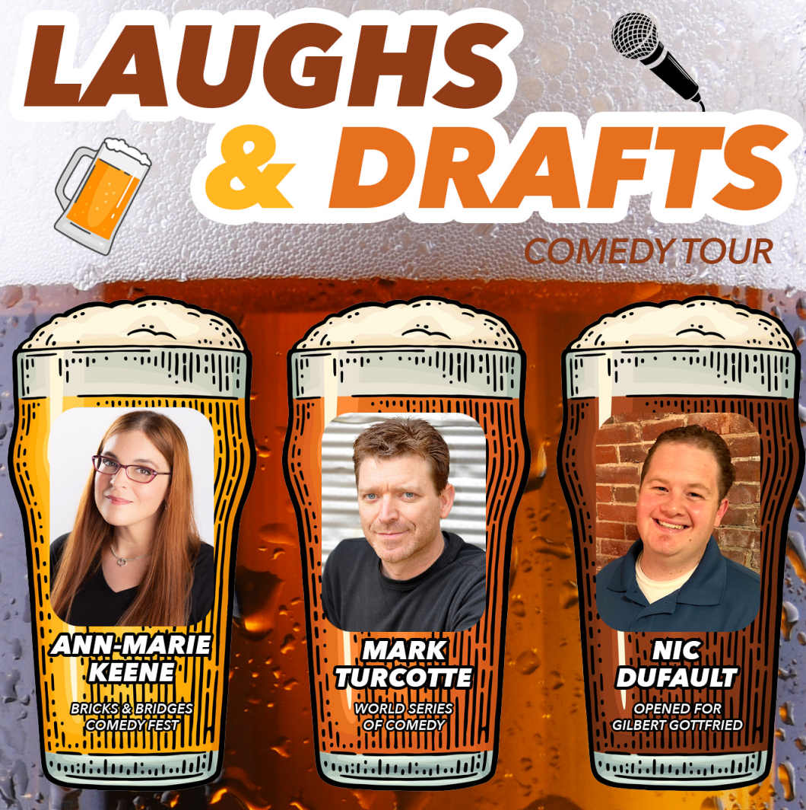  NEW LIVE MUSIC SERIES  Two For Jackson  NFL PLAYOFFS
15  MUG CLUB DAY!  $4 SELTZERS  NFL WILD CARD  WEEKEND | 16 MONDAYS  $5 MARGARITAS  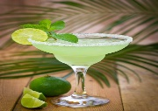 | 17  $5 Maine Crafts  $7 Maine Spirits | 18  7pm  SHIPYARD SPECIALS | 19  Drinking w/ LINCOLN!  All Drafts $5 | 20  FRIDAY KARAOKE  7pm | 21  NEW LIVE MUSIC SERIES JUSTIN CARVER 6p  NFL PLAYOFFS
22  MUG CLUB DAY!  $4 SELTZERS  NFL PLAYOFFS | 23 MONDAYS  $5 MARGARITAS | 24  $5 Maine Crafts  $7 Maine Spirits | 25  7pm  SHIPYARD SPECIALS | 26  Drinking w/ LINCOLN!  All Drafts $5 | 27  FRIDAY KARAOKE  7 pm | 28  NEW LIVE MUSIC SERIES BARNEY MARTIN 6p
29  MUG CLUB DAY!  $4 SELTZERS  NFL PLAYOFFS | 30 MONDAYS  $5 MARGARITAS | 31  $5 Maine Crafts  $7 Maine Spirits | 7pm  SHIPYARD SPECIALS | Drinking w/ LINCOLN!  All Drafts $5 | FRIDAY KARAOKE  7 pm | NEW LIVE MUSIC SERIES

