SEPT 2022 :
BURGER Of The Month: “THE SKIPPY BURGER”

SUNDAY | MONDAY | TUESDAY | WEDNESDAY | THURSDAY | FRIDAY | SATURDAY
 | $5 MARGARITAS  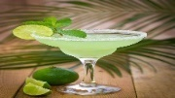 |  | 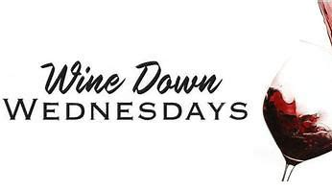  Featuring NEW WINES* | 1 Talls For  Smalls  ACOUSTIC OPEN JAM 7pm | 2  * LIVE MUSIC*  MIKE & PAUL  7pm | 3
4  MUG CLUB | 5 HAPPY LABOR DAY  $5 MARGARITAS | 6  7pm | 7  $5 House Wine  $5 Off Bottles | 8 NFL KICKOFF  BUFF vs RAMS  Talls For  Smalls  ACOUSTIC OPEN JAM 7pm | 9  * LIVE MUSIC*  BRYAN FRATES  7pm | 10  * LIVE MUSIC*  WAYNE MORPHEW  7pm
11  MUG CLUB  PATS/MIA 1pm | 12 $5 MARGARITAS | 13  7pm | 14  $5 House Wine  $5 Off Bottles | 15 THURS FOOTBALL  KC/ LAC  Talls For  Smalls  ACOUSTIC OPEN JAM 7pm | 16  * LIVE MUSIC*  Kris HYPE  7pm | 17  * LIVE MUSIC*  KIDS AT PLAY  7pm
18  MUG CLUB  PATS/PITT 1pm | 19 $5 MARGARITAS | 20  7pm | 21  $5 House Wine  $5 Off Bottles | THURS FOOTBALL  PITT/CLEV  22 Talls For  Smalls  ACOUSTIC OPEN JAM 7pm | 23  * LIVE MUSIC*  JUSTIN CARVER  7pm | 24  * LIVE MUSIC*  DAS WULF  7pm
25  MUG CLUB  PATS/Balt 1pm | 26 $5 MARGARITAS | 27  7pm | 28  $5 House Wine  $5 Off Bottles | 29 THURS FOOTBALL  Talls For  Smalls  ACOUSTIC OPEN JAM 7pm | 30  * LIVE MUSIC*  CALI CRUSH 7p

