February 2022 : ENTERTAINMENT CALENDAR
FEATURE of the Month: “THE BIG GAME BURGER ”
ALL DAY HAPPY HOUR | 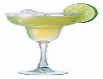  Margarita  Monday | WINE & DINE!  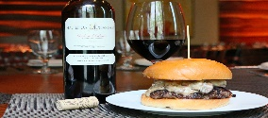  $20 Bottles of Wine | 1  $5 MAINE CRAFTS  $7 MAINE LIQUOR | 2  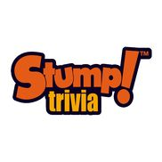  THURS. $5 TAPS  Drinking w Lincoln | 3  $5 FOOD/BEERS  SHELLY COOMBS  6 pm | 4 COMEDY NIGHT 7pm
5  ALL DAY HAPPY HOUR | 6  Margarita  Monday | 7 WINE & DINE!  $20 Bottles of Wine | 8  $5 MAINE CRAFTS  $7 MAINE LIQUOR | 9  THURS. $5 TAPS  Drinking w Lincoln | 10  $5 FOOD/BEERS  J COLE  6 pm | 11  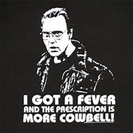  EAT MORE  COWBELL!
12 ALL DAY HAPPY HOUR  Take Home Platters  Available for the Game!  Sliders/Wings/Ribs | 13  Margarita  Monday | 14 WINE & DINE!  $20 Bottles of Wine | 15  $5 MAINE CRAFTS  $7 MAINE LIQUOR | 16  THURS. $5 TAPS  Drinking w Lincoln | 17  $5 FOOD/BEERS  TJ SWAN  6 pm | 18  EAT MORE  COWBELL!
19  ALL DAY HAPPY HOUR | 20  Margarita  Monday | 21 WINE & DINE!  $20 Bottles of Wine | 22  $5 MAINE CRAFTS  $7 MAINE LIQUOR | 23  THURS. $5 TAPS  Drinking w Lincoln | 24  $5 FOOD/BEERS  ALEX ROY  6 pm | 25  EAT MORE  COWBELL!
26  ALL DAY HAPPY HOUR | 27  Margarita  Monday | 28  WINE & DINE!  $20 Bottles of Wine | $5 MAINE CRAFTS  $7 MAINE LIQUOR | THURS. $5 TAPS  Drinking w Lincoln | $5 FOOD/BEERS | BOOK YOUR  FUNCTION IN  OUR SIDEBAR  ROOM

